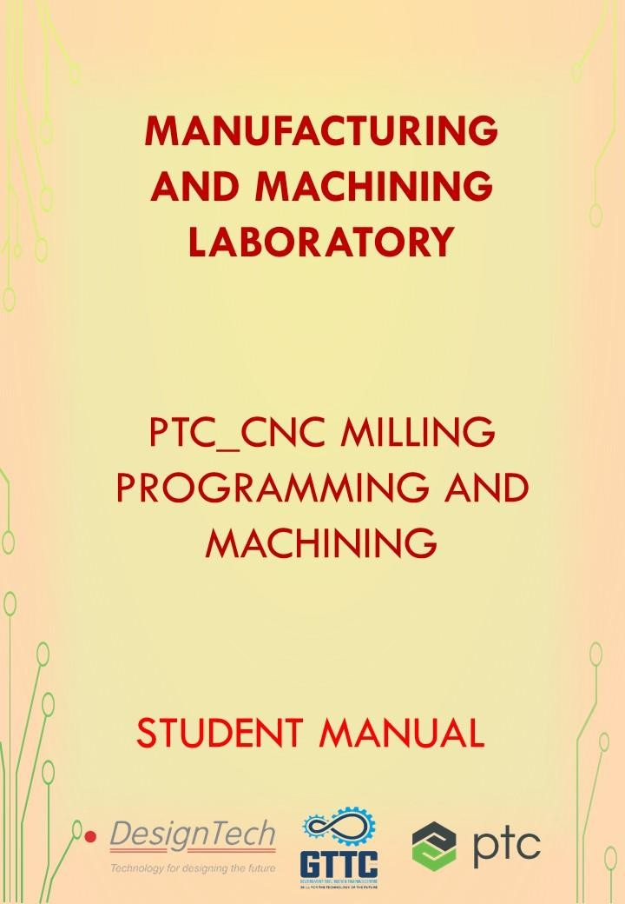

**MANUFACTURING AND MACHINING LABORATORY**

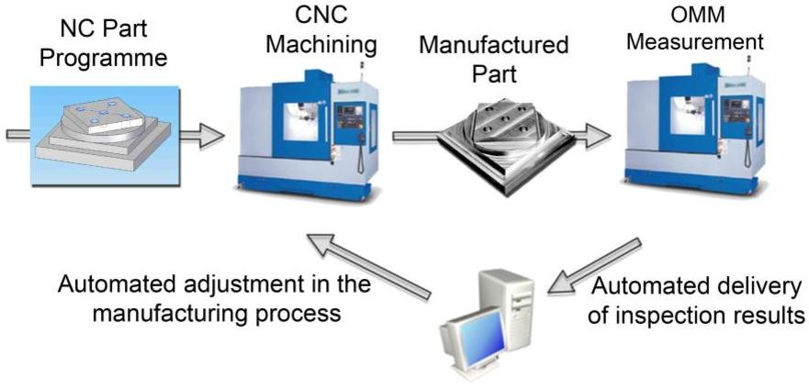This lab allows you to visualize your Machining simulation in a virtual environment and which can be further developed and optimized. PTC Creo software package is used to achieve this and which helps you to save time, money and effort to manufacture new parts.

In this lab, you will be learning basic coding for the milling work pieces and different operations like Facing, Profiling, Slot milling, Drilling and Tapping, etc. Installation of PLM Components and integration of PLM software to Creo Parametric and MS Office.

The list of courses offered,

|  |  |  |
| --- | --- | --- |
| **S. No** | **Name of the Course** | **Duration** |
| 1 | Creo for Production Engineers | 60 Hours |
| 2 | Specialization program in PLM - Wind chill | 50 Hours |
| 3 | PTC_CNC Milling Programming and Machining | 60 Hours |

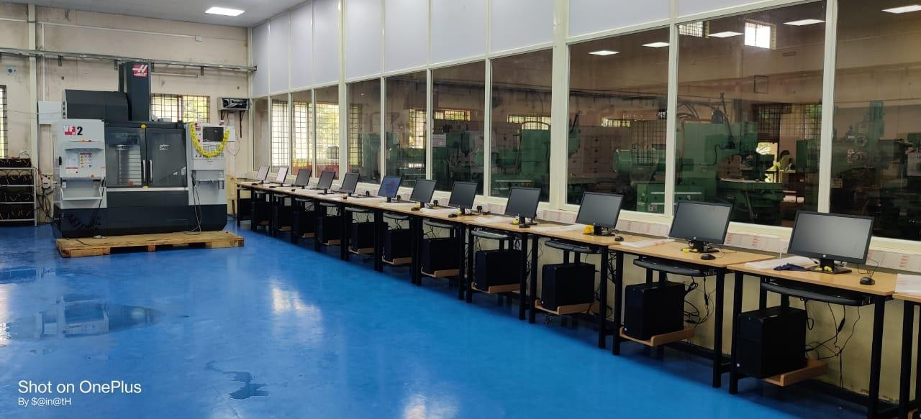

**PTC_CNC MILLING PROGRAMMING AND MACHINING**

CNC stands for computer numerical control. It is a machine controlled by a computer. Its external appearance is similar to that of an NC machine. Tape or Computer Keyboard or Tutor Keyboard is used as input media for CNC machines. For NC machines tape is to be fit and repeated to produce repeated jobs. But for CNC machines tape is fit once and the program is stored in the memory and can be run repeatedly to produce repeated jobs. It contains two distinct controls, one is the CNC controller which doses the function of program decoding interpolation, diagnostics machine actuation, etc. Another is the programmable logic controller (PLC), which does spindle on-off, coolant on-off, turret operation, etc.

|  |  |  |
| --- | --- | --- |
| **S. No** | **Name of the Course** | **Duration** |
| 1 | PTC_CNC Milling Programming and Machining | 60 Hours |

### SOFTWARE PACKAGES

1. Creo parametric 6.0.3.0
2. Windchill

### Hardware

1. CNC Machine
2. Compressor
3. Dryer

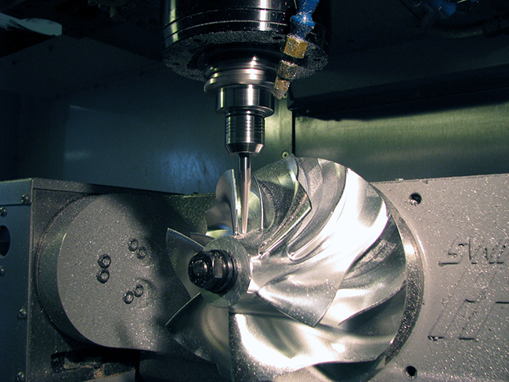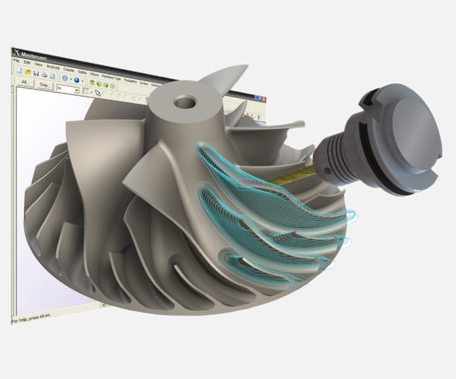

Table of Contents

1. Introduction to Manufacturing Processes 5

What is Manufacturing? 5

Types of Manufacturing Processes 6

Casting and Foundry Processes 6

Forming and Metal working Process 8

Joining and Assembly Process 9

Machining Processes 11

1. Introduction to CNC Machines 12

Types of CNC Milling Machines 13

Types of Peripheral Milling 13

Types of Milling Operations 14

1. Elements of CNC Machines 15

Mechanical elements of CNC Milling machine 16

Electrical components of CNC machines 19

Work flow of CNC Machine 22

1. Introduction to CNC Programming 23

Right hand thumb rule for CNC machine 23

ISO machine tool axis 24

Milling machine co-ordinate systems 26

1. Fundamentals of CNC Programming 27

Fundamental of CNC programming 27

Calculations in CNC Machining 35

1. Introduction to Milling controller 37

Introduction to Milling Controller 37

Introduction to Different Modes 39

Create a New Program 40

1. Cutting tool Parameters Selection 42

CNC Tooling System 42

CNC Tool Holders 44

1. Work holding devices 48

Types of Work Holding Devices 49

Temporary work holding Device 49

Modular Work Holding Devices 50

Permanent Work Holding Devices 51

1. Basic CNC Milling Programming 52

Basic of Milling machining operation 52

# Introduction to Manufacturing Processes

### Objectives:

* + What is manufacturing?
  + Different types of Manufacturing process
  + Casting and Foundry
  + Forming and Metal Working
  + Joining and Assembly
  + Rapid Prototyping
  + Machining.

## What is Manufacturing?

1. Manufacturing is the making of goods by hand or by machine that upon completion the business sells to a customer.
2. Items used in manufacture may be raw materials or component parts of a larger product. 3.Manufacturing usually happens on a large-scale production line of machinery and skilled labor.

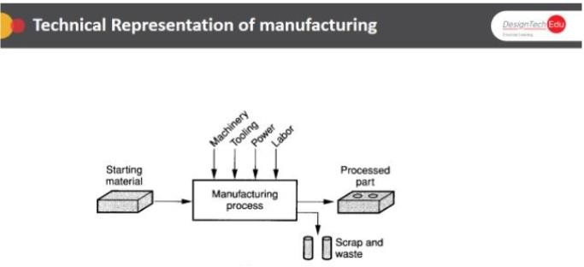

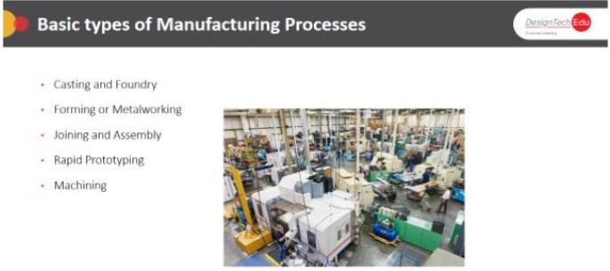

### What is Manufacturing Processes?

1. Manufacturing process are the steps through which raw materials are transformed into a final product.
2. The manufacturing process begins with the product design, and materials specification from which the product is made.
3. These materials are then modified through manufacturing processes to become the required part.

**Types of Manufacturing Processes** **Casting and Foundry Processes**

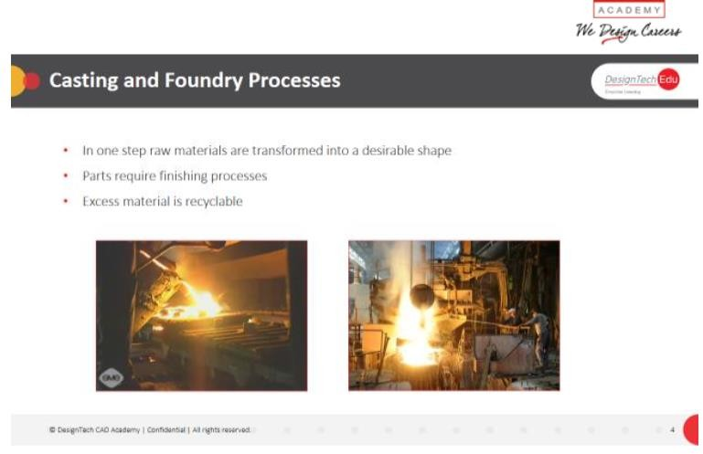

### Description:

Casting is a manufacturing process in which a liquid material is usually poured into a mold, which contains a hollow cavity of the desired shape, and then allowed to solidify. The solidified part is also known as a casting, which is ejected or broken out of the mold to complete the process A foundry is a factory that produces Metal castings. Metals are cast into shapes by melting them into a liquid, pouring the metal in a mold, and removing the mold material or casting after the metal Has solidified as it cools. The most common metals processed are aluminum and cast iron.

However, Other metals, such as bronze, brass, steel, magnesium, and zinc, are also used to produce castings in foundries. In this process, parts of desired shapes and sizes can be formed.

In metalworking, casting involves pouring liquid metal into a mold, which contains a hollow cavity of the desired shape, and then allowing it to cool and solidify. The solidified part is also known as a casting, which is ejected or broken out of the Mold to complete the process. Casting is most often used for making Complex shapes that would be difficult or uneconomical to make by other methods.

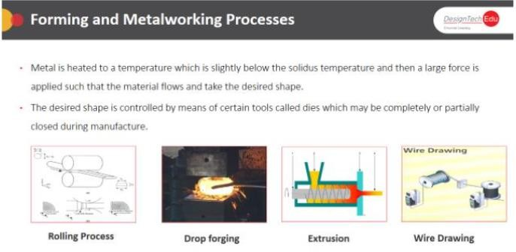

## Forming and Metal working Process

### Description:

Forming, metal forming, is the metalworking process of fashioning metal parts and objects through mechanical deformation; the workpiece is reshaped without adding or removing material, and its mass remains unchanged. Forming operates on the materials science principle of plastic deformation, where the physical shape of a material is permanently deformed. Compressive forming involves those processes where the primary means of plastic deformation is uni or multiaxial compressive loading. Rolling, where the material is passed through a pair of rollers Extrusion, where the material is pushed through an orifice

Die forming, where the material is stamped by a press around or onto a die Forging, where the material is shaped by localized compressive forces Indenting, where a tool is pressed into the work piece Tensile forming Tensile forming involves those processes where the primary means of plastic deformation is uni-or multiaxial tensile stress. Stretching, where a tensile load is applied along the longitudinal Axis of the work piece

Expanding, where the circumference of a hollow body is increased by tangential loading Recessing, where depressions and holes are formed through tensile loading

### Combined tensile and compressive forming

* This category of forming processes involves those operations where the primary means of plastic deformation involves both tensile stresses and compressive loads.
* Pulling through a die
* Deep drawing
* Spinning
* Flange forming
* Upset bulging
* Bending (metalworking)
* This category of forming processes involves those operations where the primary means of plastic deformation is a bending load.

### Shearing

* This category of forming processes involves those operations where the primary means of plastic deformation is a shearing load.

## Joining and Assembly Process

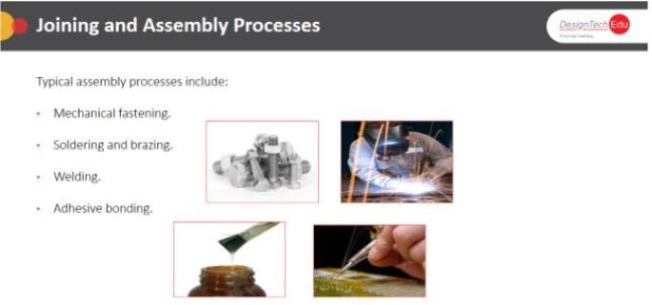

### Description:

### Welding

* In the welding process, two or more parts are heated and melted or forced together, causing the joined parts to function as one.
* In some welding methods a filler material is added to make the merging of the materials easier.
* There are many different types of welding operations, such as the various arc welding, resistance welding and oxyfuel gas welding methods.
* These will not be covered in this introduction, however.

### Brazing

* During the brazing process a filler metal is melted and distributed in between multiple solid metal components after they have been heated to the proper temperature.
* The filler metal must have a melting point that is above 840 degrees Fahrenheit but below
* The melting point of the base metals and the metal must also have high fluidity and Wettability.
* No melting of the base metals occurs during brazing.

### Soldering

* Soldering is similar to brazing; the only real difference being that in soldering the melting point of the filler metal is below 840 degrees Fahrenheit.
* Again, no melting of the base metals occurs, but the filler metal wets and combines with the base metals to form a metallurgical bond.

### Adhesive Bonding

* In adhesive bonding a filler material, called an adhesive, is used to hold multiple closely spaced parts together through surface attachment.
* The adhesive is a nonmetallic substance; often it is a polymer.

### Mechanical Assembly

* Various fastening methods are used in mechanical assembly to mechanically attach two or more parts together.
* Usually fasteners are used, being added on during the assembly operation. Sometimes, however, fastening involves the shaping of one of the components being assembled without the need of separate fasteners.
* Mechanical fastening can be divided into methods that allow for easy disassembly, threaded fasteners, and those that do not, rivets.

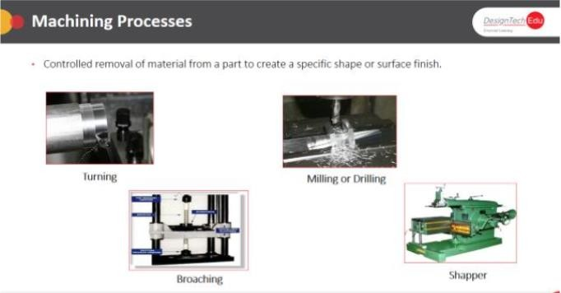

## Machining Processes

### Description:

* Machining is the broad term used to describe removal of material from a workpiece, it covers several processes, which we usually divide into the following categories:
* Cutting, generally involving single-point or multipoint cutting tools, each with a clearly defined geometry.
* Abrasive processes, such as grinding.
* Non-Traditional machining processes, utilizing electrical, chemical, and optimal sources of energy.
* It is important to view machining, as well as all manufacturing operations, as a system consisting of the workpiece, the tool and the machine.
* The introduction topic in this section covers primers on topics like mechanics & shear bending in machining, and heat in machining.
* The traditional machining includes primers on turning, milling, drilling, and grinding. It also includes computer applications which are being supported by the primers. The non-Traditional machining includes primers on the topics like ECM, EDM, AFM, USM.

# Introduction to CNC Machines

### Objectives:

* Introduction to CNC Milling
* Types of CNC Milling machines
* CNC Milling Machine Operations

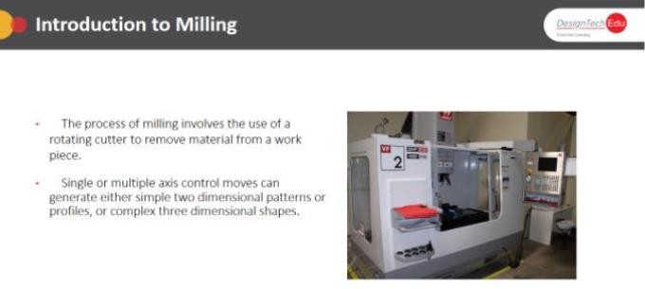

### Introduction to CNC Milling

* The manufacturing industry relies heavily on computer-numerical control (CNC) machining, including operations that once used engineer-operated equipment like routers, shaping machines, vertical millers and center lathes.
* The many CNC machine advantages mean operator-required equipment has in some cases been replaced entirely.
* Manufacturers of many types across many industries choose the advantages of CNC machining for their fabrication and manufacturing applications.
* It provides efficient, expedient and precise production capacity ideal for creating large quantities of items normally produced with a router, grinder, center lathe, vertical miller or shaping machine.
* The computer-numerical control offers a few types of financial and production advantages over the conventional method.
* In manual lathing, for example, there must be a skilled technician for every machine, while with CNC machining, one skilled person Can operate several machines.

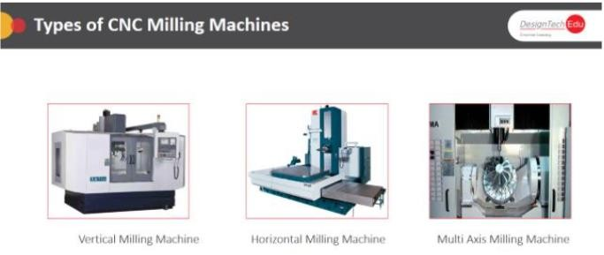

## Types of CNC Milling Machines

### Description

* Most of the milling machine are constructed of column and knee structure and they are classified in two main types namely Horizontal Milling Machine and Vertical Milling Machine.
* The name Horizontal or Vertical is given to the machine by virtue of its spindle axis.
* Horizontal machines can be further classified into Plain Horizontal and Universal Milling Machine.
* The main difference between the two is that the table of a Universal Milling Machine can be set at an angle for helical milling while the table of a Plain Horizontal Milling Machine is not Horizontal Milling Machine
* In Horizontal Milling machine the spindle axis is mounted in horizontally
* In Vertical Milling machine the spindle axis is mounted in Vertically

## Types of Peripheral Milling

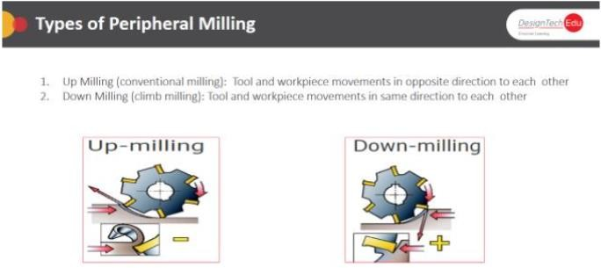

### Description:

* In up-milling (conventional milling), the feed direction of the cutting tool is opposite to its rotation.
* The chip thickness starts at zero and increases toward the end of the cut.
* Cutting forces tend to push the cutter and workpiece away from each other.
* High tensile stresses, caused when the edge is leaving the workpiece, will often result in rapid edge failure.
* Forces, mainly radial, will tend to lift the workpiece from the table.
* Thick chips at the exit from the cut will reduce tool life in down-milling (climb milling), the cutting tool is fed with the direction of rotation.
* Down-milling is always preferred wherever the machine tool, fixture and workpiece will allow.
* In peripheral down-milling, the chip thickness will decrease from the start of cut, gradually reaching zero at the end of cut. This prevents the edge from rubbing and Burnishing against the surface before engaging in the cut.
* The large chip thickness is advantageous, and the cutting forces tend to pull the Workpiece into the cutter, holding the cutting edge in the cut.

## Types of Milling Operations

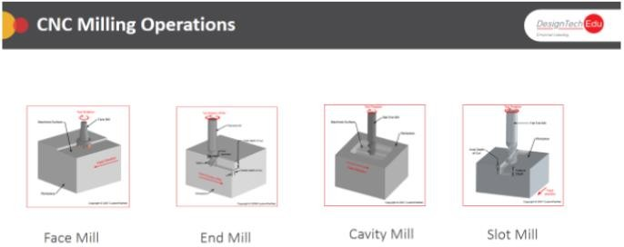

### Description:

### Face Milling:

* This operation is used to produce a machined surface perpendicular to the axis of the cutter. In Face Milling cutting action occurs along face of the Cutter. Face milling is used to cut flat surfaces (faces) into the work-piece.

### End Milling:

* This is the operation of production of the flat surface which may be vertical, horizontal or at an angle in reference to the table surface. The cutter used in this operation is called as End Mill.

### Cavity Milling:

* Use cavity Mill operations to remove large volumes of material in planar levels that are perpendicular to a fixed tool axis.

### Slotting:

* 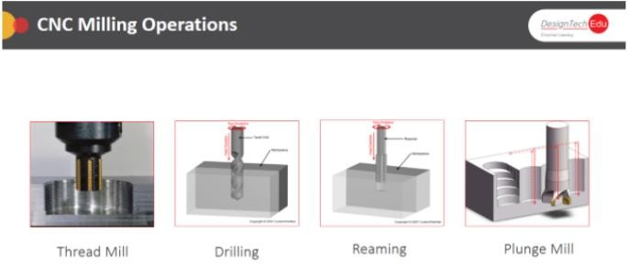This is the operation of production of key ways, grooves and slot of Varying shapes and sizes.

### Thread Milling:

* This is the operation of production of threads by using a single or multiple thread milling cutters.

### Drilling:

* Drilling is a cutting process that uses a drill bit to cut a hole of circular cross-section In solid materials. The drill bit is a rotary cutting tool, often multipoint.

### Reaming:

* A reamer is a type of rotary cutting tool used in metalworking
* The process of enlarging the hole is called reaming

### Plunge Milling:

* In plunge milling, the cutting is performed at the end of the tool instead of at the periphery, which is advantageous due to the change in the direction of the cutting forces from predominately radial to axial.
* In general, plunge milling is an alternate method when side milling is not possible due to vibrations.

# Elements of CNC Machines

### Objectives:

In this lesson you were introduced to the following concepts:

* Mechanical Elements of CNC milling Machine
* Electrical Elements of CNC milling Machine
* CNC Milling Machine Workflow

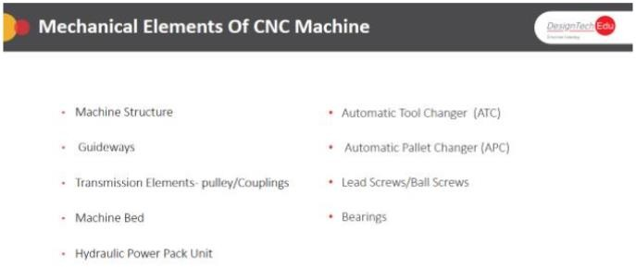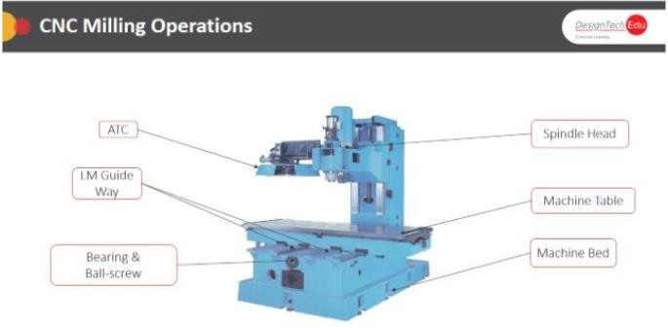

## Mechanical elements of CNC Milling machine

### Description:

### Machine Bed

* Base of the Machine
* It gives support to different fixed and operations parts
* It is usually single piece casting of semi-steel(Cast-iron)
* It is having high damping capacity to resist vibrations
* Easy mounting on the floor machine Table
* It is generally made up of cast-iron.
* Size & shape of table depends on
* work-piece and type of machine
* Work-piece accuracy depends on machine table accuracy.

### Automatic Tool Changer (ATC)

* It increases tool carrying capacity of the machine
* It reduces non-production time
* Milling Machine –ATC

### Turning Machine/Lathe Machine –Turret

* Drum Type changer ATC (up to 30 tools)
* Chain Type Changer ATC (More than 30 tools)

### Automatic Pallet Changer (APC)

* The palletizing system on the machine reduces unproductive time during machining.
* Machining can be carried out on one pallet, while the others can be used for preparation seating and clamping of work-pieces etc.)
* The palletizing system consists of two, or more pallets (per customer requirements).
* LM Guide ways
* It is important element of Machine tool.
* Main function is to make sure that the cutting tool or machine tool operative element moves a long pre-determined path.
* LM Guide ways provides a smooth & linear motion in machine tool due to which higher accuracy & precision can be obtained.

### Bearings

* A bearing is a machine element that constrains relative motion to only the desired motion.
* It reduces friction between moving parts.
* The term "bearing" is derived from the verb “to bear";A bearing being a machine element that allows one part to bear (i.e., to support) another
* Main function of bearing is to give support to rotating shaft to transfer energy from, one end other
* Transmission Elements pulleys/Couplings Coupling is a device used to connect two shafts together at their ends for the purpose of transmitting power
* To provide connection of shafts of units made separately
* To allow misalignment of the shafts or to introduce mechanical flexibility.
* To reduce the transmission of shock loads
* To introduce protection against overloads.
* To alter the vibration characteristics

### Ball Screws

* A ball screw is a mechanical linear actuator that translates rotational motion to linear motion with little friction.
* A threaded shaft provides a helical raceway for ball bearings which act as a precision screw.

### Machine Bed

* Base of the Machine
* It gives support to different fixed and operations parts
* It is usually single piece casting of semi-steel(Cast-iron)
* It is having high damping capacity to resist vibrations
* Easy mounting on the floor machine Table
* It is generally made up of cast-iron.
* Size & shape of table depends on work-piece and type of machine
* Work-piece accuracy depends on machine table accuracy.

### Spindle Head

* In machine tools, a spindle is a rotating axis of the machine, which often has a Shaft at its heart. The shaft itself is called a spindle. It includes Shaft, Bearings, O-rings, Draw Bar and Coolant accessories.

## Electrical components of CNC machines

### Description:

### Stabilizer

* Stabilizer, a kind of voltage regulator in electronics.
* Gun stabilizer, or gyrostabilizer, a device that helps a moving tank's gunner to aim the gun.
* Drilling stabilizer, part of the bottom hole assembly in oil drilling.
* Sway bar, a bar linking the two sides of an automotive suspension.
* Camera stabilizer.

### Machine Controller

* It is also known as HMI (Human Machine Interface)
* It’s an inbuilt Computer which handles all the elements of machine tools and also gives feedback each and every axis positions in 3d graphical Display.
* Operator can make a program and also execute it in machining mode for machining the work part on the machine controller.
* Machine Control Unit: The machine control unit is the heart of the CNC System. There are two sub units in machine control unit.

### The Data Process Unit

* On receiving the part program, the DPU firstly interrupts and encodes the part program into internal machine codes.
* The interpolator of DPU then calculate the intermediate positions of the motion in terms of basic length units which is the smallest unit length that can be handled by the controller.
* The calculated data are processed to Control Loop Unit for further action.

### Description:

### Control Loop Unit

* The data from the DPU are converted into electrical signals in the CLU to control the driving system to perform the required motion.
* Other functions such as machine spindle On/Off, Coolant On/Off, Tool Clamp On/Off are also controlled by this unit according to the internal machine codes.

### Drive System

* A drive system consists of amplifier circuits, stepping motors or servomotors and ball lead-screws.
* The MCU feeds control signals (position and speed) of each axis to the amplifier circuits. The control signals are augmented to actuate stepping motors which in turn rotate the ball lead-screws to position the machine table.

### Feedback System

* In order to have a CNC machine work accurately the positional values and speed of the axes needs to be constantly updated.

Positional Feedback Device

* Position feedback devices gives information of the position of the axis Positional feedback devices are two types
* Linear encoder for direct positional measurement (Linear Axis)
* Rotary encoder for angular and indirect linear measurements (Rotary Axis) Velocity Feedback Device
* This device gives information of the velocity of the axis
* It can be used for the linear or rotary axis
* Its measures velocity in term of voltage generated from a tachometer mounted at the end of motor shaft.

### Servomotor

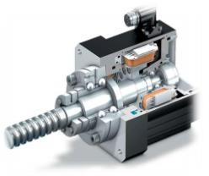

* A servomotor is a rotary actuator or linear actuator that allows for precise control of angular or linear position, velocity and acceleration.
* It consists of a suitable motor coupled to a sensor for position feedback
* A servo motor consists of several main parts, the motor and gearbox, a position sensor, an error amplifier and motor driver and a circuit to decode the requested position.
* Servomotors are used in applications such as robotics, CNC machinery or automated manufacturing

### Stepper Motor

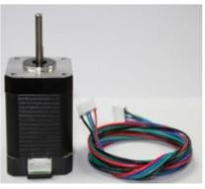

* Conventional servo motors are classified as continuous rotation motors
* Stepper motors rotate through a specific number of degrees, or steps, then stops.
* Each incoming pulse results in the shaft turning a specific angular distance.
* Stepper motors can control velocity, distance, and direction of mechanical load

## Work flow of CNC Machine

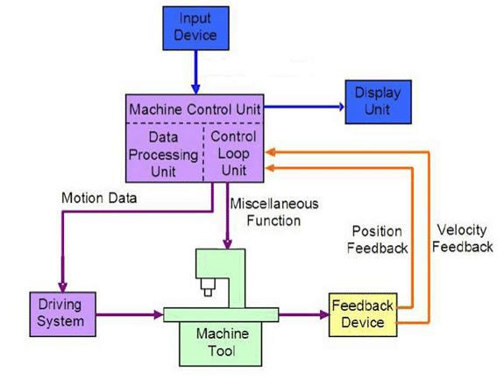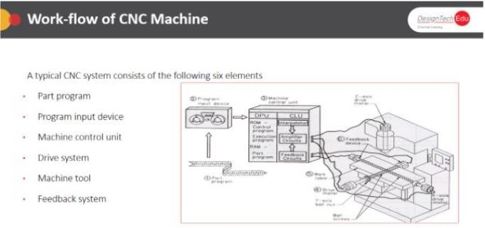

# Introduction to CNC Programming

### Objectives

At the end of the day participants should able to

* Understand ISO machine tools axis.
* Right hand thumb rule for CNC machine.
* Coordinate systems in NC programming. Description:
* In addition of the above linear movement along the X, Y and Z, axes it is possible to control rotation around each axis.
* This controllable axis is marked as A, B and C

## Right hand thumb rule for CNC machine

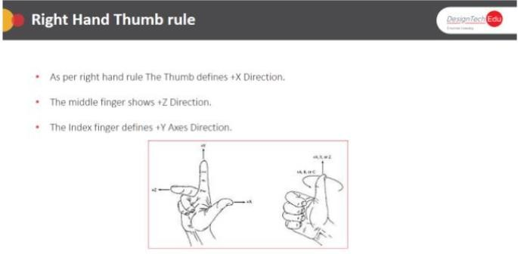

### Description:

* To determine the positive, or clockwise, direction about an axis, close your hand with the thumb pointing out.
* The thumb may represent the X, Y, or Z direction and the curl of the fingers may represent the clockwise, or positive, rotation about each axis.
* These are known as A, B, and C and represent the rotary motions about X, Y, and Z, respectively.

## ISO machine tool axis

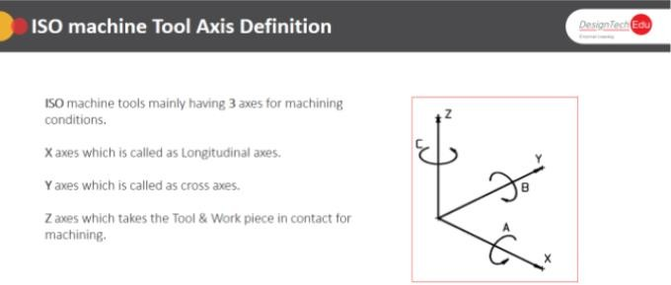

### Types of coordinate system:

Coordinate system enable the exact description of all points on a work plane or room. Basically,

There are two types of coordinate system

1. Cartesian Coordinate system
2. Polar Coordinate system

We having 2 types of dimensioning methods to Describe the Points in both above Coordinate

Systems which are:

1. Absolute Dimensioning
2. Incremental Dimensioning

### 2D COORDINATE SYSTEM

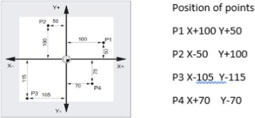

In the two-dimensional coordinate system e.g. In the X, Y coordinate system, each point on the plane is explicitly

Defined. The distance from the y axis is called the x coordinate and the distance from the X axis is called Y coordinate. These coordinates have a positive or a negative sign.

### 3D COORDINATE SYSTEM

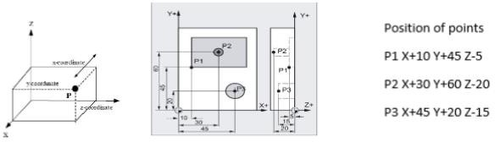

In the Three-dimensional coordinate system e.g. In the X, Y & Z coordinate system, each point on the plane is explicitly defined with its Height or Depth. The distance from the y axis is called the x coordinate and the distance from the X axis is called Y coordinate. Distance from the top to depth is

Defined as Z axis. These coordinates have a positive or a negative sign. Position of points

P1 X+10 Y+45 Z-5 P2 X+30 Y+60 Z-20 P3 X+45 Y+20 Z-15

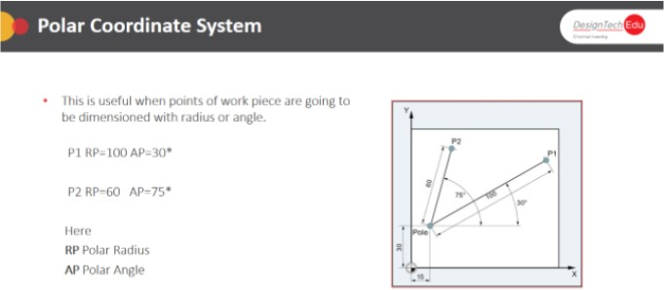

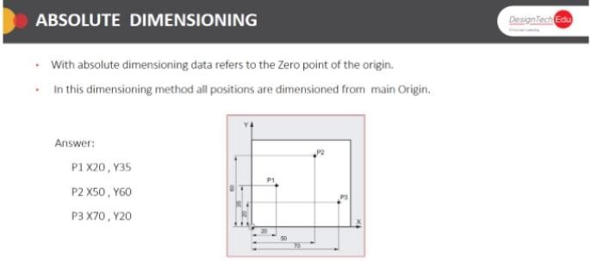

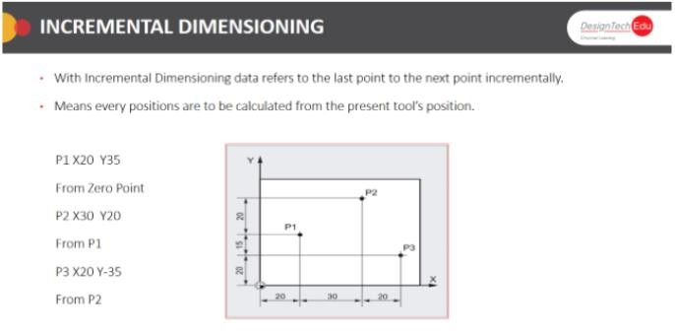

## Milling machine co-ordinate systems

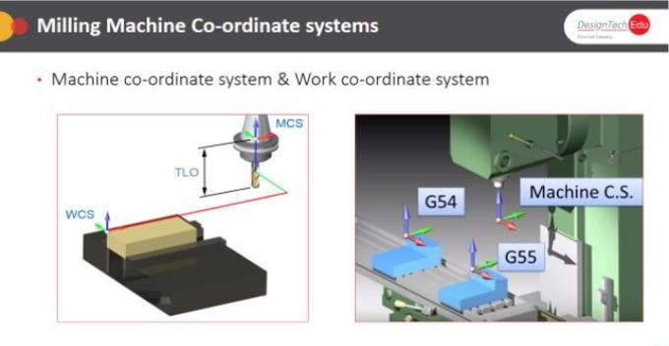

# Fundamentals of CNC Programming

### Objectives

At the end of the day participants should able to

* Fundamental of CNC programming
* Calculations in CNC Milling Programming

### Description:

## Fundamental of CNC programming

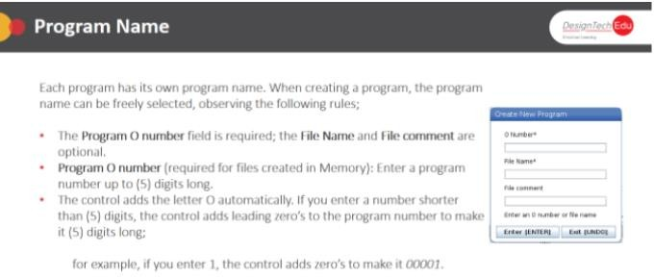

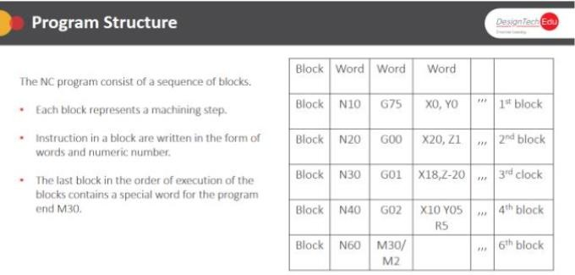

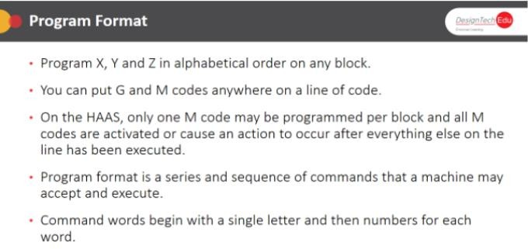

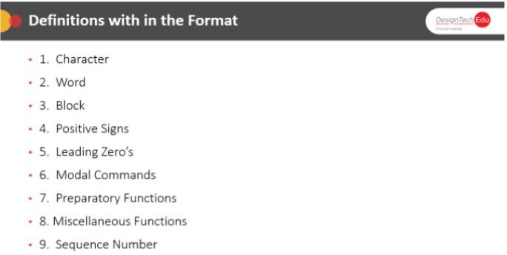

### Description

N BLOCK NUMBERING

* The blocks in a NC program can be identified by the block numbering its consist of character “N” and a positive number e.g.
* N10 G00 X00 Y00 Z00
* N20...
* The Block numbers are must be unique how we can find the blocks of remaining point easily. I, J, K?
* I Coordinates of circle center point in X direction
* J Coordinates of circle center point in Y direction
* K Coordinates of circle center point in Z Direction
* I, J, K is used to define the center of a circle for circular movements.
* 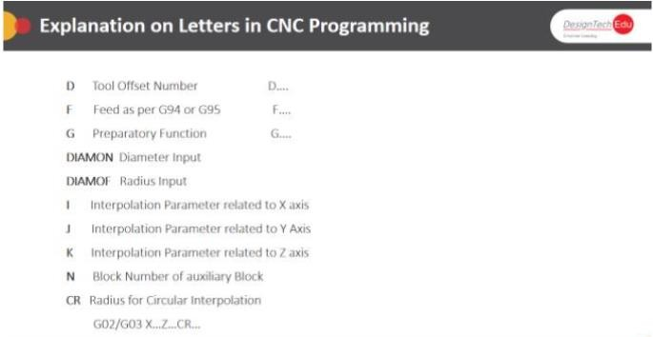They are usually entered incrementally. These codes are used in G02/g03instead of CR or R.

### Description:

Chamfer Address

* CHF –Chamfer in general use –Insert a chamfer of the specified chamfer length
* CHR –Chamfer in the contour definition –Insert a chamfer of the specified leg length
* ANG –Angle for the specification of a straight line for the contour definition - specifying a straight line when using G0 or G1 if only one end-point coordinate of the plane is known

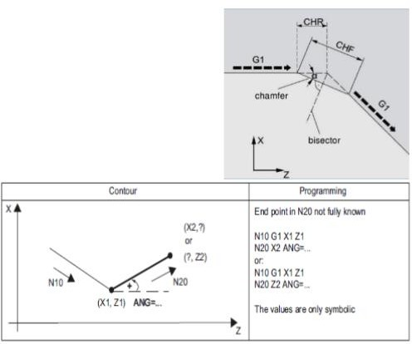

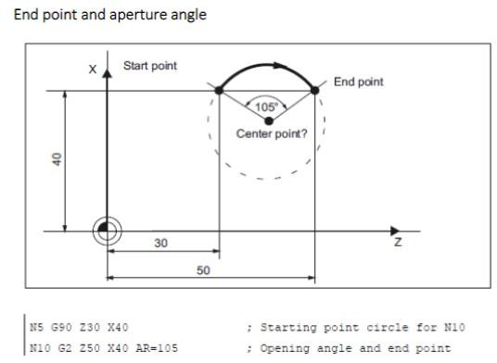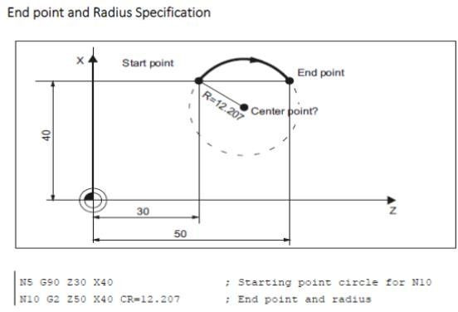

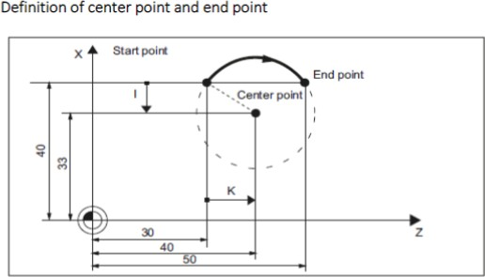

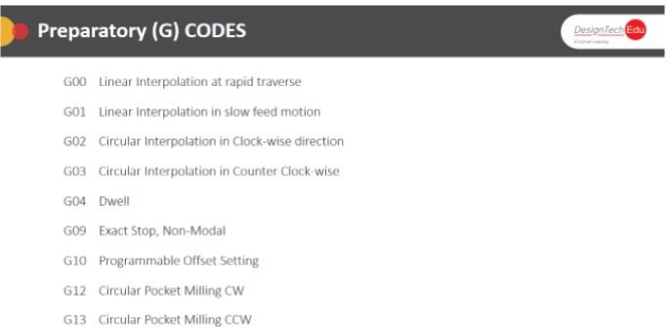

### Description:

### WHAT IS G00?

#### G00 MEANS RAPID TRAVRSE

Rapid traverse means the tool movement in X, Y or Z di

Reaction at maximum speed defined by machine tool manufacturer.

The rapid traverse movement G00 is used for rapid positioning of the tool without cutting area, But not for direct work piece machining.

Programming Example: N10 G00 X100 Z65;

#### WHAT IS G01?

G01 MEANS LINEAR INTERPOLATION IN SLOW FEED MOTION.

By this code we can move all the axis at slow feed as we program in “F” feed.

By this code we can machine the work piece in linear motion as per required feed rate according to the spindle speed without collusion as per safety point positioned in G00. G01 X... Y... Z... F...;

#### WHAT IS G02?

G02 MEANS CIRCULAR INTERPOLATION IN CLOCK-WISE DIRECTION

By this code we can machine radius on the work piece in 2D dimensioning Its code isg02 X... Y....R...;

For Milling X axis last point after completing radius Y or Z axis last point after completing radius

R for radius size to be machined on work piece

#### WHAT IS G03?

G03 MEANS CIRCULAR INTERPOLATION IN COUNTER CLOCK WISE DIRECTION

As same like G02, by

This code we can machine radius on the work piece in 2D dimensioning in counter clock- wise direction its code isg03 X... Y....R...; for Milling

X axis last point after completing radius

Y or Z axis last point after completing radius R for radius size to be machined on work piece

#### WHAT IS G04

G04 means Dwell Time G04 is called the

Dwell command because it makes the machine stop what it's doing or Dwell for a specified length of time

* It's helpful to be able dwell during a cutting operation, and also to facilitate various non-cutting operations of the machine.
* G4F...; Dwell time in seconds
* G4 S...; Dwell time in spindle revolutions

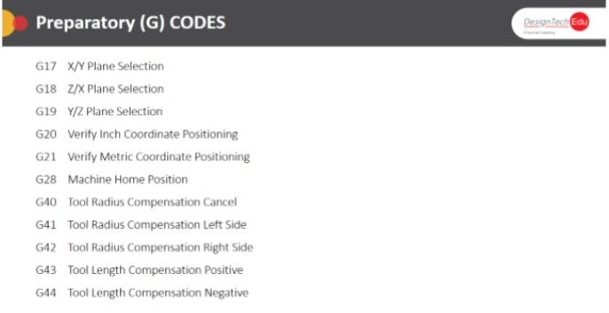

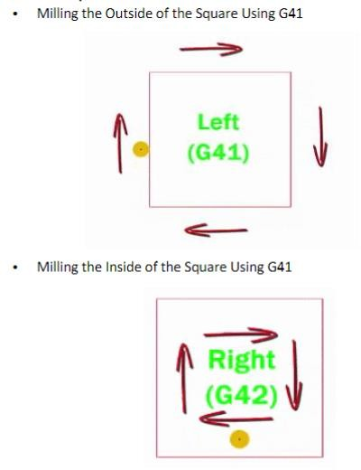

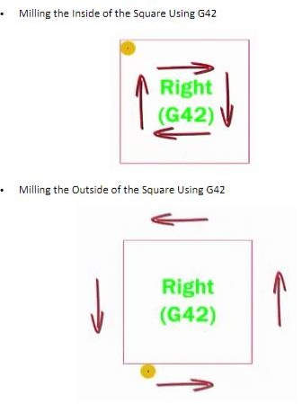

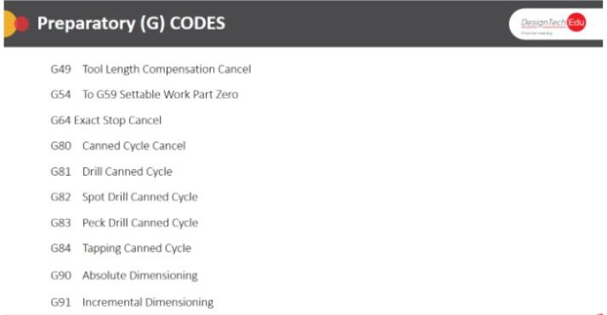

#### G90 MEANS ABSOLUTE DIMENSIONING

* With absolute dimensioning data refers to the Zero point of the current active coordinate system G54 to G59 or G500.
* In this dimensioning method all positions are dimensioned from main Work Part Zero.

#### G91 MEANS INCREMENTAL DIMENSIONING

* With Incremental Dimensioning data refers to the tool position to the next position incrementally.
* Means every Positions are to be calculated from the present tool’s position.

## Calculations in CNC Machining

### Description:

Speeds and feeds are at the heart of all machining. Learning the CNC codes or using a conversational control can be achieved in a relatively short period of time. Selecting the right speeds and feeds is almost as much art as it is science.

Safety –always an important consideration–don’t jeopardize your or another operator’s safety for the sake of speed.

Rigidity –if your setup is not rigid, you can toss a part or tool out of the machine, experience excessive chatter, fail to achieve acceptable surface finish, fail to maintain dimensions and so on.

Machinability –all materials have unique machinability characteristics. You’ve no doubt observed aluminum machines easier than steel. Cutting too material –high speed steel, carbide, ceramic, etc. Available Horsepower –Machinability determines the horsepower requirements to cut the Material. If you don’t have the horsepower, you will have to lighten your cuts to avoid stalling the spindle.

### Tool geometry–

Tools that have positive cutting geometry cut more freely than do tools with negative geometry, but are limited in the amount of shock and interrupted cuts they can take. Some materials cut much better with negative geometry, others with neutral or positive geometry.

### Heat –

Machining creates a lot of heat and it is going to go into the tool, the material, the chips that are removed and so on. Too much heat will quickly break down your tool. Too much heat can cause the material to expand and make it difficult to control part size.

### Chip control –

Your ability to control the chips made during the machining process is an indication of having chosen the correct speeds, feeds and tool geometry.

### Surface Finish –

there is a direct relationship between cutting feeds and tool radius to surface finish.

All of the above factors (and many more) affect or are directly affected by speeds and feeds.

# Introduction to Milling controller

### Objectives

At the end of the day participants should able to

* Introduction to Milling Controller
* Different operating Modes
* Creating a Cutting tool
* Creating a New program

## Introduction to Milling Controller

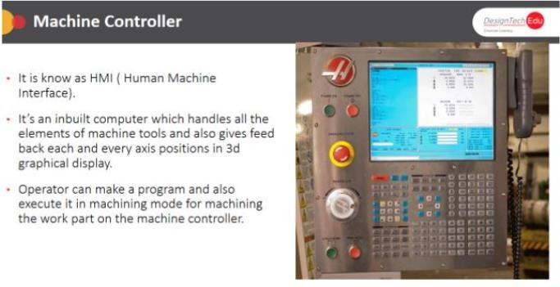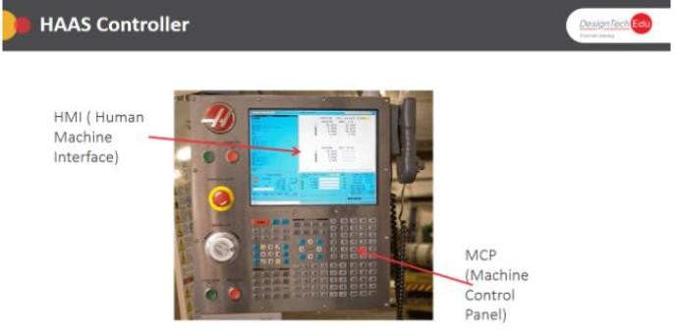

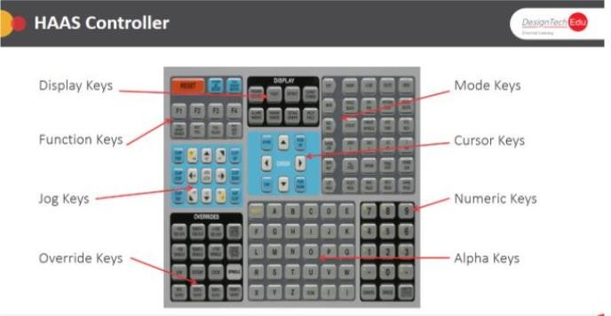

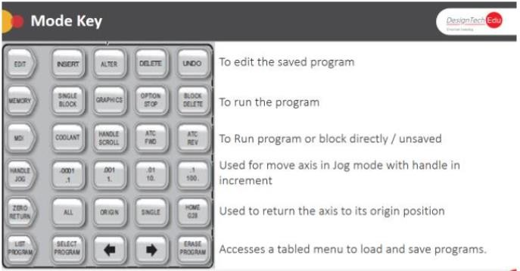

## Introduction to Different Modes

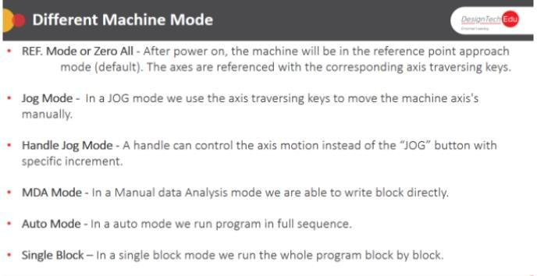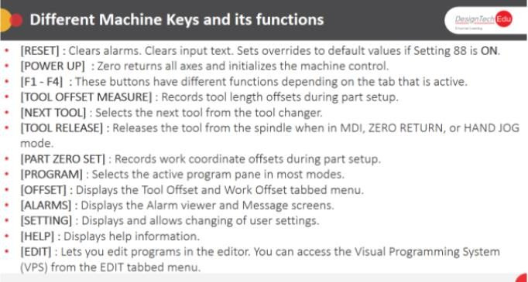

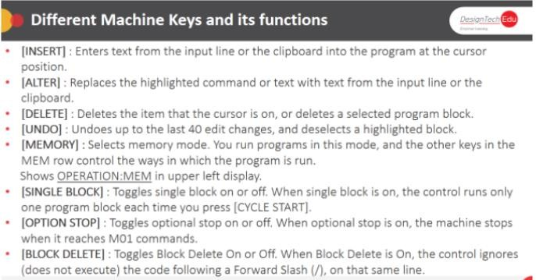

## Create a New Program

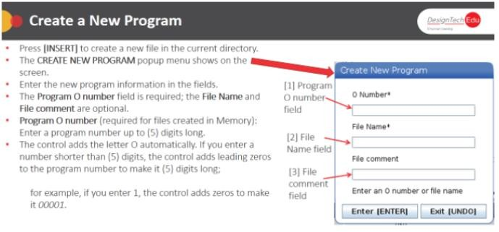

### Description:

### MANUAL MODE (JOG MODE)

* Note that this differs from Manual Data Input (MDI) mode.
* In manual mode, your CNC machine acts like a standard machine.
* You can operate it just like you would any other machine that doesn’t use programming. You can push buttons, turn wheels, and turn switches on or off.
* The difference between manual mode and manual data input mode is that with MDI, you can do certain things that you can’t in manual mode. More on that in a second.

### MANUAL DATA INPU TMODE (ALSO CALLED MDI OR MDA MODE)

* In this mode, you can do some programming and data entry. However, everything you enter will only be done once.
* If you need all the functions done again, you’ll have to program them again.
* The advantage of this mode is that you can do manual operations that simply cannot be done in manual mode.
* Some CNC machines, for Example, don’t have manual controls to change the spindle speed.

### SINGLE BLOCK MODE

* Each CNC program is made of blocks.
* They may be numbered something like N20, N30, and N40. When you enter this mode, just a single block of code executes.
* Additionally, This means your CNC machine only stops moving on its access. For example, the machine spindle keeps turning, and coolant continues to flow too.

### EDIT MODE

* Just as it sounds, you can enter programs in your CNC machine’s memory, or you can modify current programs.
* Programs are usually organized by number, and you can make the program you want active.
* You can also insert new info into the program, alter its current info, or delete info from it.
* •Some, but not all, CNC programs allow you to cut, paste, find, and replace data just like you would in word processing software.
* AUTOMATICMODE/PROGRAMOPERATIONMODE
* Again, no surprises here. In this mode, you get to find out how well you did with creating your program. So, take a deep breath, and execute yours.
* Most CNC machines allow you to see the commands executed as they happen. So, if you notice a mistake, you will be able to easily identify where it is in your program.

# Cutting tool Parameters Selection

### Objectives

At the end of the day participants should able to

* Recognize all the Cutting tool inserts.
* Tool Holder nomenclature
* Describe Construction Tools
* Explain the Cutting Parameter Selection.

## CNC Tooling System

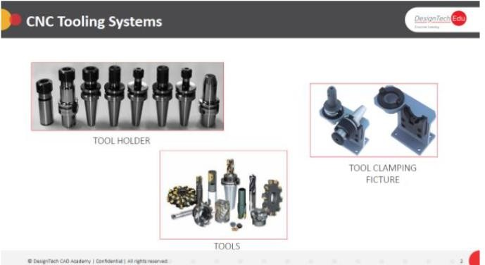

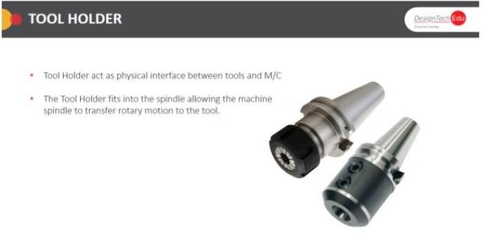

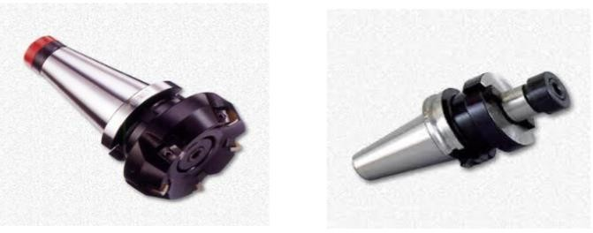

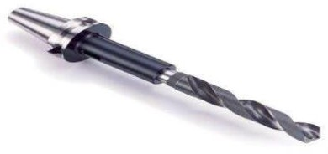

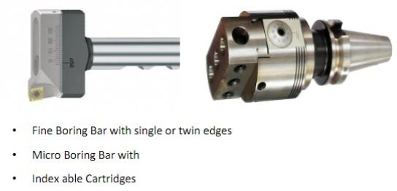

## CNC Tool Holders

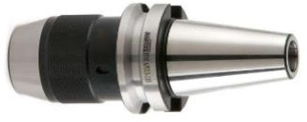

* Taper Shank
* Flange
* Gauge Length
* Socket of Collets
* Pull stud face mill and Shoulder Arbor
* Face Mill holders consist of an arbor and a pair of bolt-on drive keys to securely hold cutter.
* A Face Mill construction takes a modular form, with the shank (or arbor) made separately from the body of the cutter, called a “shell
* Morse taper tool holder is used to chucking the Morse taper sleeve or Drill & chamfer tool. It was developed by Stephen Morse
* Morse taper drill sleeves are used as reduction or sizing up of Morse taper tools.
* The tang is found in this tool holder to eject the Morse taper drill or tool.

### Boring Bar Adaptor

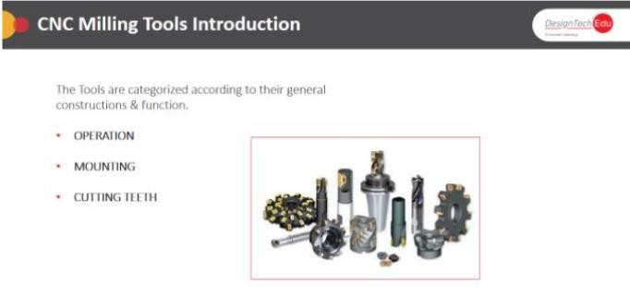

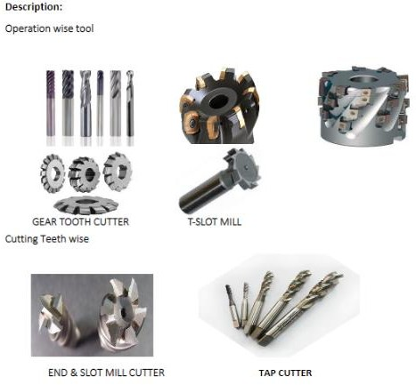

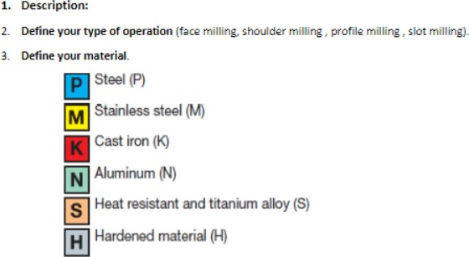

Fine Boring Bar with single or twin edges

* Micro Boring Bar withindex able Cartridges Drill Chuck
* Drill Chuck adaptor is known as keyless chuck.
* It’s having an integral keyless adaptor.
* It’s mostly used to hold flat shank Drills, End mill Cutter, Slot mill Cutters and Edge finder.
* It can hold the tools & revolve it at the accuracy of 10-20 microns play.

### Machine

Spindle Taper Shank Specification

* A machine taper secures cutting tools and other accessories to machine spindle.
* The various types of taper are:

### CAT

* It was developed on American standards by Caterpillar.

### BT

* It was developed in Japan. It’s similar to CAT but uses dual flange pull

### NMTB

* It was developed by the National Machine Tool Builders for quick change.

### HSK

* It The hollow shank tool is designed to strengthen the tool grip at speed

### MORSE

* It was invented by Stephen A. Morse. It used to the end of drills & Reamers ND Mill
* They are used in milling applications such as profiling, plunging, slotting, Spigot, Pocket-milling etc.
* This milling cutter basically slot mill cuts in all directions, as it has cutting teeth all around and center-cut.

### BULL MILL CUTTER

* which refers to a cutter having a corner radius that is fairly large, although less than the spherical radius (half the cutter diameter) of a ball mill; For example, a 20-mm diameter cutter with a 2-mm radius corner.
* This usage is analogous to the term bull nose center referring to lathe centers with truncated cones; in both cases, the silhouette is essentially a rectangle with its corners truncated (by either a chamfer or radius Don). PLAIN, BULL, BALLNOSE MILLSFACE MILLANGULAR MILLGEAR TOOTHCUTTERT-SLOT MILLSELL-END MILL SELL-END MILL BALL-NOSE End Mills
* Ball-Nose end mills constructed to the same tolerance as the normal Two-Flute End Mills (SLOT) which having center cut as it the Ball-nose have center cut at ball ends.
* This type of End Mill cutters are extensively used in mold and die manufacturing Applications. Because it can work in all axis at a same time on CNC milliNg machine.

Drills

* Drills are used to create a cylindrical hole in the work piece.
* It has a cutting point at the tip of a cylindrical shaft with helical flutes.
* They are come in various types which are used in different specific applications. The base types are:
  1. Material
  2. As per Coating 3.As per styles

Drills Based on Style

Drills get their names based on styles which define and influence themThey are:

* Twist Drills
* Step Drills
* Core Drills
* Gun Drills
* Center Drills
* Index-able Drills
* PCB Through-hole Drills
* HSS stub Drills
* Jobber-Length Drills

### Description:

Define your type of operation (face milling, shoulder milling, profile milling, slot milling).

### Define your material. Select your milling cutter.

Use a close pitch cutter as first choice.

Use a coarse pitch cutter for long overhang and unstable conditions.

Use an extra close pitch cutter for short chipping materials and super alloys

### Select your insert.

Choose the insert geometry for your operation: Geometry L = Light

For light cuts when low forces / power are required Geometry M = Medium

First choice for mixed production Geometry H = Heavy

For rough operations, forging, cast skin and vibrations

# Work holding devices

### Objectives

* Types of Work Holding Devices
* Temporary work holders
* Modular work holders
* Permanent work holders

## Types of Work Holding Devices

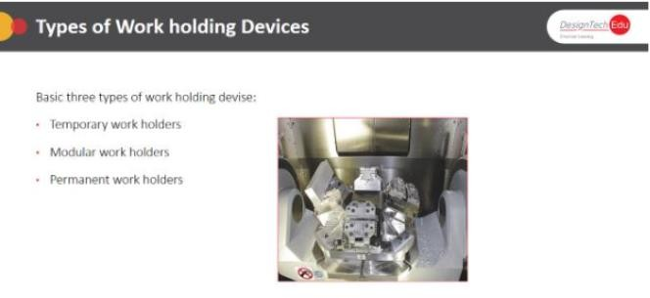

### Description:

### Why work holding Device?

Setting up the milling work piece is the most difficult part of the job work. It’s obviously required critical thinking for some complicated machining angle. As a programmer, you must know about the types of work holding devices and their appropriate Use. By the good understanding of work holding devices you can fasten the work part to the machine Table, before going for machining.

## Temporary work holding Device

The universal Chuck & Indexing chuck are also temporary holding device mostly

Used for holding the cylindrical piece for gear cutting, Hobbling or specific angular operations.

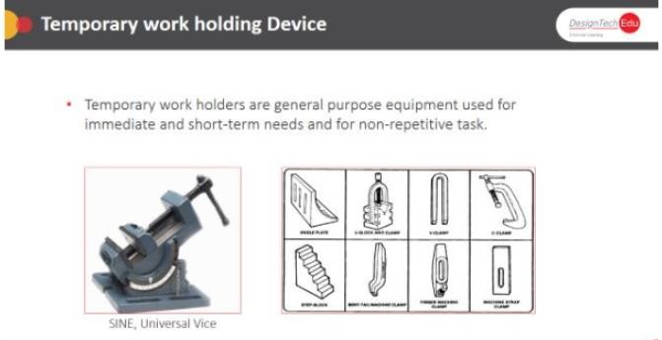

## Modular Work Holding Devices

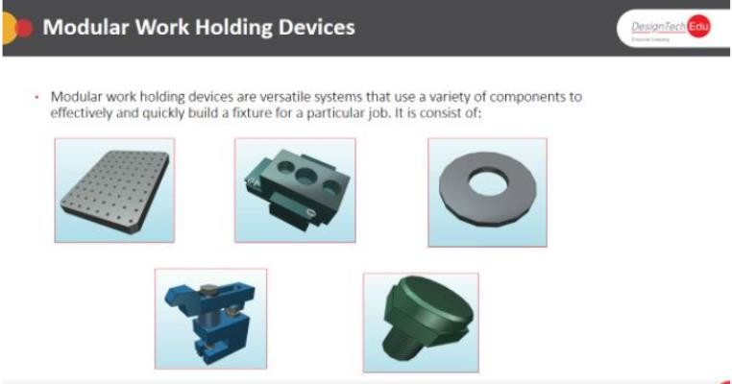

## Permanent Work Holding Devices

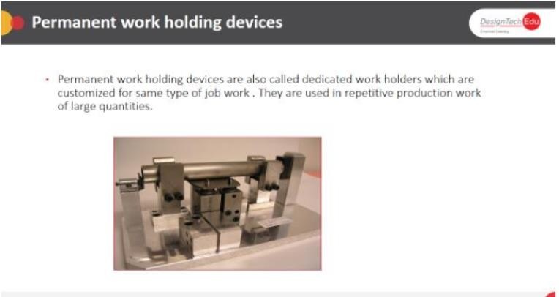

### Description:

Function of Permanent work holding devices

* The permanent work holding devices basically fixtures can locate, Hold and support the work securely.
* They are specially designed for holding the particular work part.
* They can hold the uneven means odd-shaped parts which can’t be held by any other way.
* They are used in high production job work.
* They are always made to secure maximum clamping surfaces.
* They are also designed with keys to assure the positive alignment with table.

### Benefits of Permanent work holding devices

* The permanent work holding devices reduce the setting up time of work part on machine.
* They give surety of easy setup and desired accuracy.
* They are reduced manufacturing cost when identical work part machined.
* They increase the productivity and decrease the manpower dependence.
* They help operation conditions for higher values machine setup.
* They reduce the operator’s efforts by which they get safety while working on machine.

# Basic CNC Milling Programming

### Objectives

At the end of the day participants should be able to

* Basic of Milling machining operation.
* ISO code programming for milling operations
* Hand on practice on 808D milling control manual programming

## Basic of Milling machining operation.

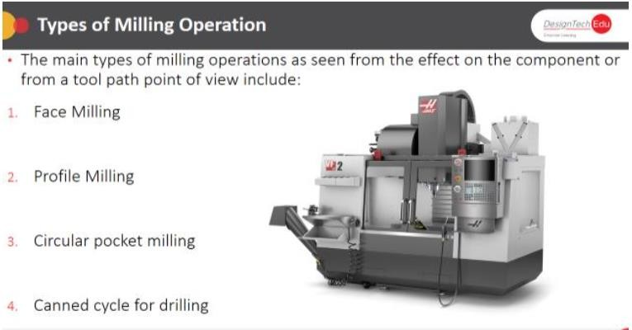

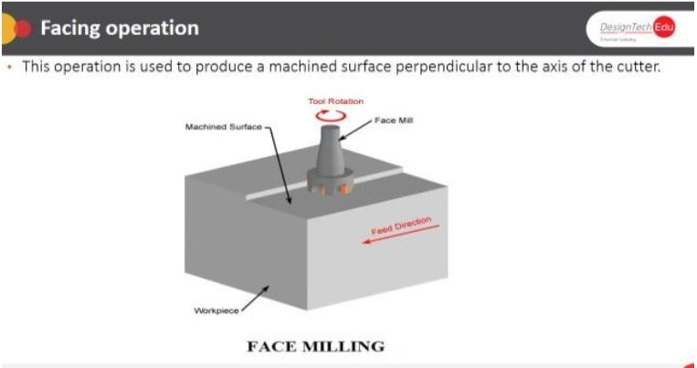

* Facing is often the first machining operation.
* It is used to cut away excess material and finish the highest flat face of the part.
* Depending on how much stock is removed, several roughing cuts may be required.
* A smaller finish pass ensures a flat surface and good surface finish.
* Use a face mill when possible for all but the smallest part.
* The large diameter of facing mills and multiple carbide insert cutting edges provide for very high material removal rates. High speed loop transitions between cut passes produce a fluid tool motion that place less stress and wear on the CNC machine.

### Rules for Facing:

* Because face mills do not plunge well, start the tool path far enough away from the part so the tool does not plunge into the stock material.
* Be aware that saw cut stock can vary considerably in thickness from one part to another: as much as .05 in or more.
* When planning roughing passes, be sure to account for the worst-case stock material– maximum height and add additional roughing passes as needed. It is better to have a “air cut” or two with The shortest stock than to have the tool engage too much material for the highest which could cause the tool to break or the part to be pushed out of the vice or fixture.
* Facing tool paths do not use cutter compensation (CDC).

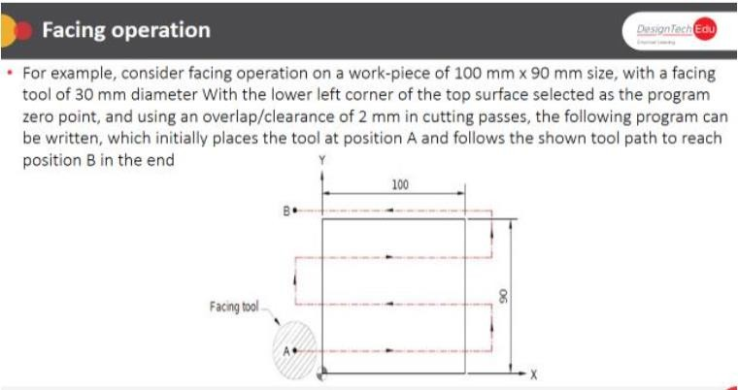

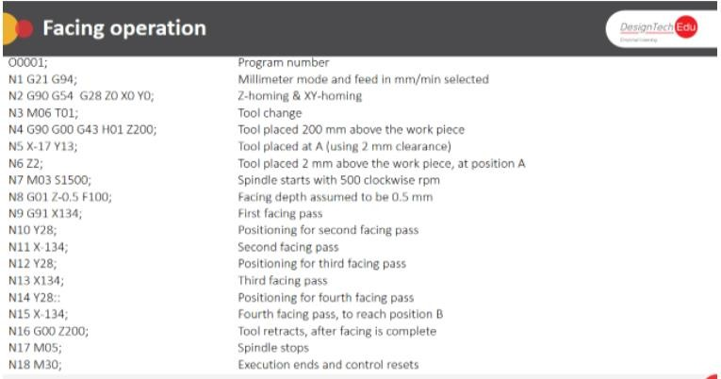

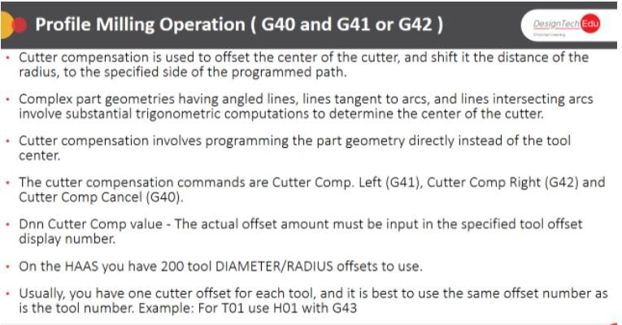

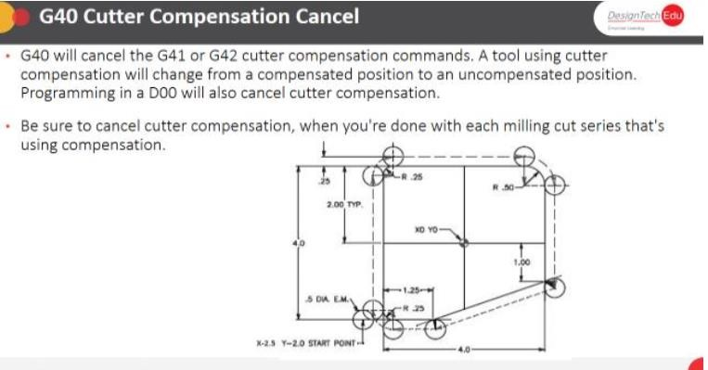

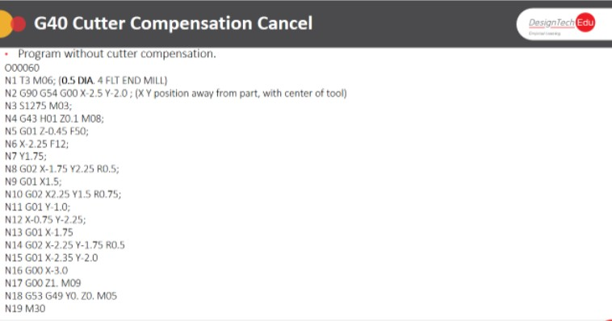

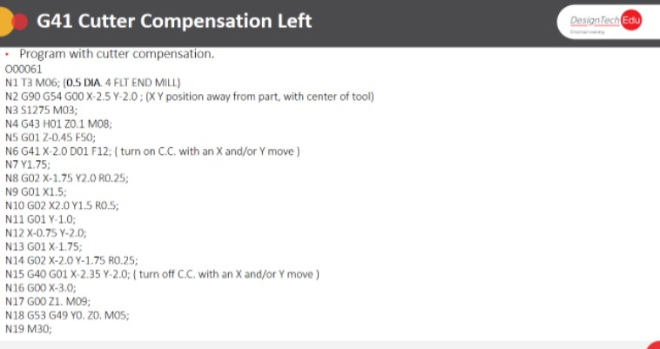

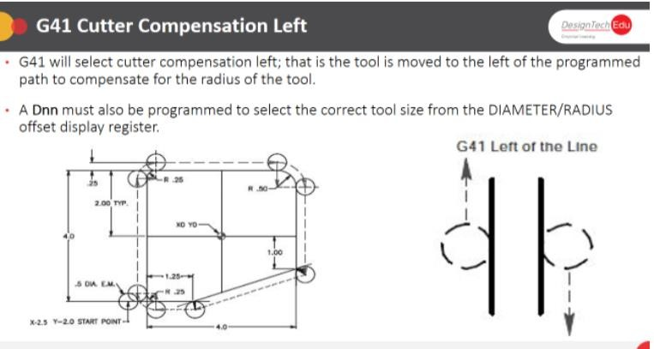

### Description:

### Profile Programming

Contour operations are used to rough and finish outside part walls as shown in Figure 6. Use Cutter Diameter Compensation (CDC) on high tolerance features so the tool path can be adjusted at the machine if needed To account for tool wear and deflection.

Rules for Contouring:

* Only use CDC when needed. If using new tools and conservative machining parameters, Features will likely be within .005 inches of the programmed path without adjustment.
* Start the tool path off The part to allow CDC to be fully in effect for the entire operation. The Combined Line Arc Lead in/out moves shown in Figure 4 work for most contours. The line is for activating/deactivating compensation, and the arcs blend the path into the part wall smoothly.
* Set a rapid height value to clear all clamps or other obstacles between cuts.
* Rough the walls and leave a constant thickness of material for the finish operation. This Ensures even cutting pressure on the finish pass and thus a more accurate part.
* Extend the cut depth of full walls slightly below the bottom of the wall but be careful not to cut into the machine table or vice hard jaws! This way, when the part if flipped over to face the other side, no flashing will be left on the bottom of the walls.
* Mill tools cut well in the X direction, but not as well when plunging in Z. When possible, plunge the tool away from the part to avoid Z Moves into the stock material.
* When taking multiple depths of cut, make the last pass at full depth to remove Any marks left by previous depth cuts.
* For tall walls, consider taking one additional finish pass. This so Called “spring pass” follows the same path twice to ensure the walls are perfectly straight and not slightly tapered due to cutting pressure which causes the tool top end.

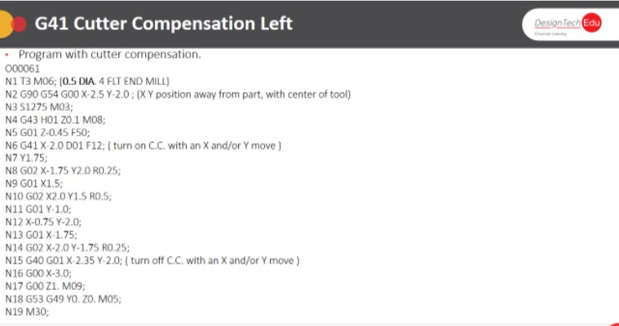

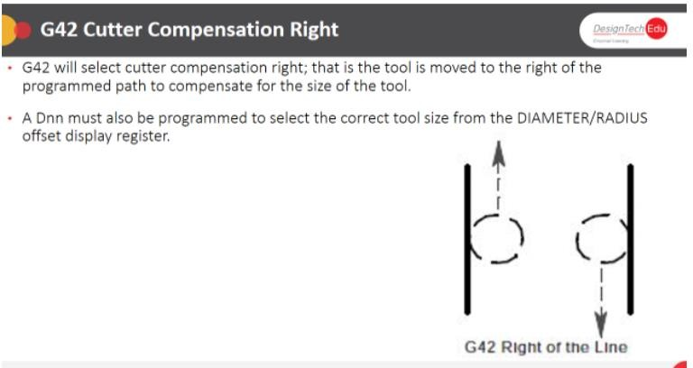

### Cutter Compensation:

* Cutter Diameter Compensation provides a way for tool paths to be adjusted at the machine to compensate for tool wear and deflection. Figure 5 shows how CDC Right (G41) causes the tool to veer to the right of the programmed path.
* The compensation value is found by measuring the part feature and subtracting the actual dimension from the desired dimension. The difference is entered in the control CDC register for the tool. The next time program is run, the tool will be offset by this value.
* CDC must be turned on or off with a line move, never an arc. Commanding G40/G41/G42 with an arc move will cause a diameter compensation error that will stop the program.
* CDC is activated at the end of the line on which it is called, as shown in Figure 5. Notice how the tool moves at an angle from the start to end of the lead in line. Activate CDC while the tool is away from the part so this angle move happens away from the finished part surfaces.

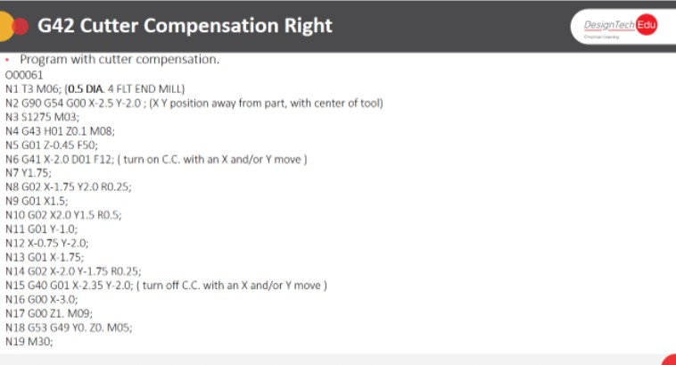

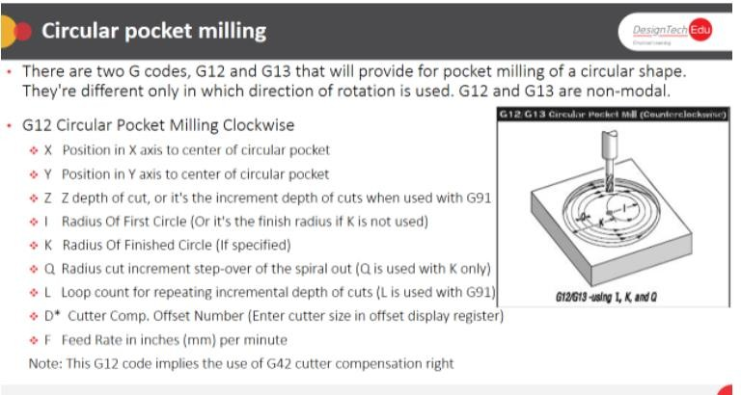

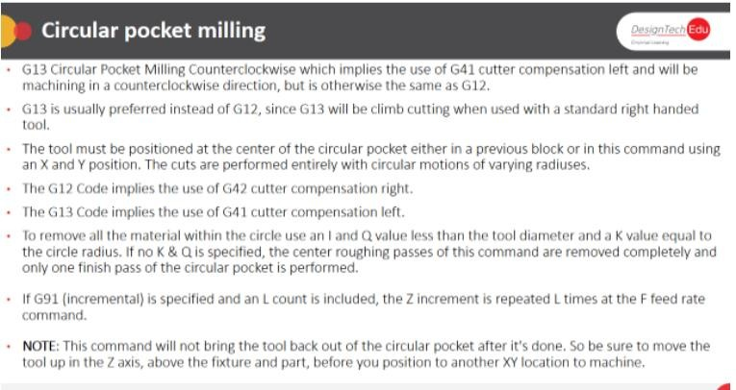

### Description: Pocketing

* + Tool paths are used to remove excess material from a raw material to get a Rectangular and Circular Pocket.
  + Rules for Pocketing:
  + Rough passes should leave a constant thickness of material on the walls and floor of the pocket to be removed by the finish passes.
  + Consider using a roughing end mill to remove most of the material. These serrated mills can remove material at a far faster rate than finish end mills. They do leave a poor finish on the floors and walls that must be finished with a separate finish tool and operation.
  + Helical moves are a good method for entering a pocket. If space does not allow a helical entry, use a center‐cutting end mill or plunge the tool through an existing hole, or a pilot hole created for this purpose. The pilot hole must be at least 50% of the tool diameter.
  + Spiral pocketing paths that start near the Centre of the pocket and move outward in a counter-clockwise direction are best because they cause the tool to continually climb cut.

